**SPH3U 5.5 Power**

1. **Power**

|  |  |
| --- | --- |
| Power: |  |
| equation |  |

How much power does a swimmer produce if she transforms 2.4 kJ of chemical energy (in food) into kinetic energy and thermal energy in 12.5 s?

A 64 kg student climbs from the ground floor to the second floor of his school in 5.5 s. The second floor is 3.7 m above the ground floor. What is the student’s power?

The student runs back down the stairs in 2.25 s. What is the student’s power?

1. **Electrical power**

|  |  |
| --- | --- |
| Power rating: |  |
| energy transformed |  |

What is the power of an electric elevator motor if it uses 2.9 x 105 J of electrical energy to lift an elevator car 12 m in 16 s?

|  |  |  |  |  |  |
| --- | --- | --- | --- | --- | --- |
| **Appliance** | **Power Rating (W)** | **Appliance** | **Power Rating (W)** | **Appliance** | **Power Rating (W)** |
| laptop |  | microwave |  | fridge |  |
| vacuum |  | dishwasher |  | stove |  |

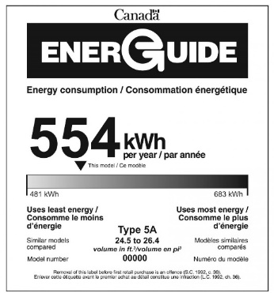

|  |  |
| --- | --- |
| Electricity metres: |  |
| EnerGuide: |  |

What is the cost of operating a 25 W light bulb 4.0 h a day for 6.0 days if the price of electrical energy is 5¢/kWh?

Twenty incandescent light bulbs are turned on for 12 h a day for an entire year to light up a store. Each bulb has a power rating of 100.0 W. The average cost of electricity is 6.0¢/kWh.

Calculate the cost of lighting the store for a year.

How much money could be saved by using CFLs, if they have a power rating of 23 W?

**Homework:** page 254: #1-2, 4-5